Day – 5 Assignment

- List all the main components you find inside a desktop PC after opening the cabinet, and write a short description (1-2 lines) for each.

Component | Short Description
Motherboard | The main circuit board that connects and allows communication between all computer components.
CPU (Processor) | The "brain" of the computer that performs calculations and executes instructions.
CPU Cooler (Fan + Heatsink) | Keeps the CPU cool by removing excess heat generated during operation.
RAM (Memory) | Temporary storage that holds data and programs currently being used by the CPU.
GPU (Graphics Card) | Processes graphics, videos, and games. Example: NVIDIA GeForce GTX 1650.
SSD (Solid State Drive) | Fast storage device used to store the operating system, applications, and files.
HDD (Hard Disk Drive) | Traditional storage device that provides large storage capacity at a lower cost.
SMPS / Power Supply Unit (PSU) | Converts AC power from the wall outlet into DC power for computer components.
Cabinet Fans | Improve airflow inside the case and help maintain safe temperatures.
SATA Cables | Connect storage devices such as HDDs and SSDs to the motherboard.
Power Cables | Deliver electrical power from the PSU to the motherboard, storage devices, and GPU.
PCIe Expansion Slots | Slots on the motherboard used for graphics cards, Wi-Fi cards, and other expansion cards.
CMOS Battery | Maintains BIOS settings and system clock when the PC is powered off.
Optical Drive (Optional) | Reads and writes CDs, DVDs, or Blu-ray discs.

2. Take clear photos or draw labelled diagrams of each step as you disassemble a desktop PC, and organize them in a document with captions explaining what you did at each step.<br><br><em><strong>Hint:</strong> Include steps like unplugging power, removing side panel, disconnecting cables, and removing RAM, HDD/SSD, and motherboard.</em>

Desktop PC Disassembly :

Step 1: Unplug the Power
Turn off the computer and disconnect the power cable from the PC.
Step 2: Remove the Side Panel
Remove the screws and carefully open the side panel of the PC case.
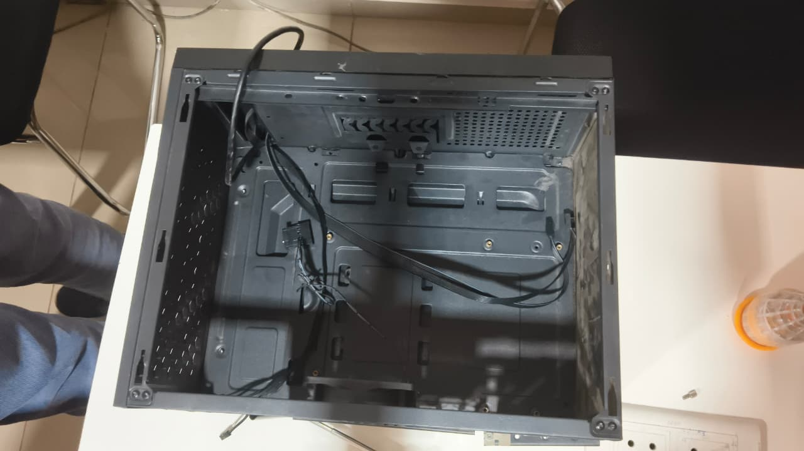
Step 3: Disconnect the Cables
Disconnect the power and data cables connected to the motherboard, GPU, HDD/SSD, and other components.
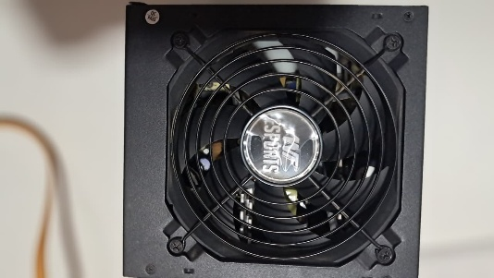

Step 4: Remove the RAM
Open the clips on both sides of the RAM slot and carefully remove the RAM module.
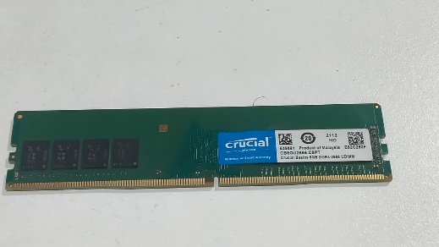

Step 5: Remove the GPU
Remove the GPU screw, unlock the PCIe slot clip, and carefully remove the graphics card.
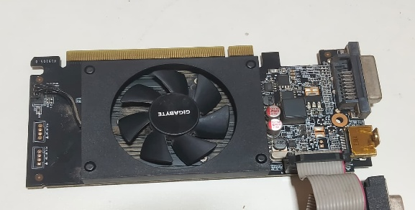

Step 6: Remove the HDD/SSD
Disconnect the power and SATA cables, then carefully remove the HDD/SSD from its mounting position.
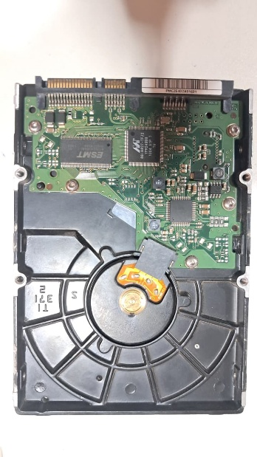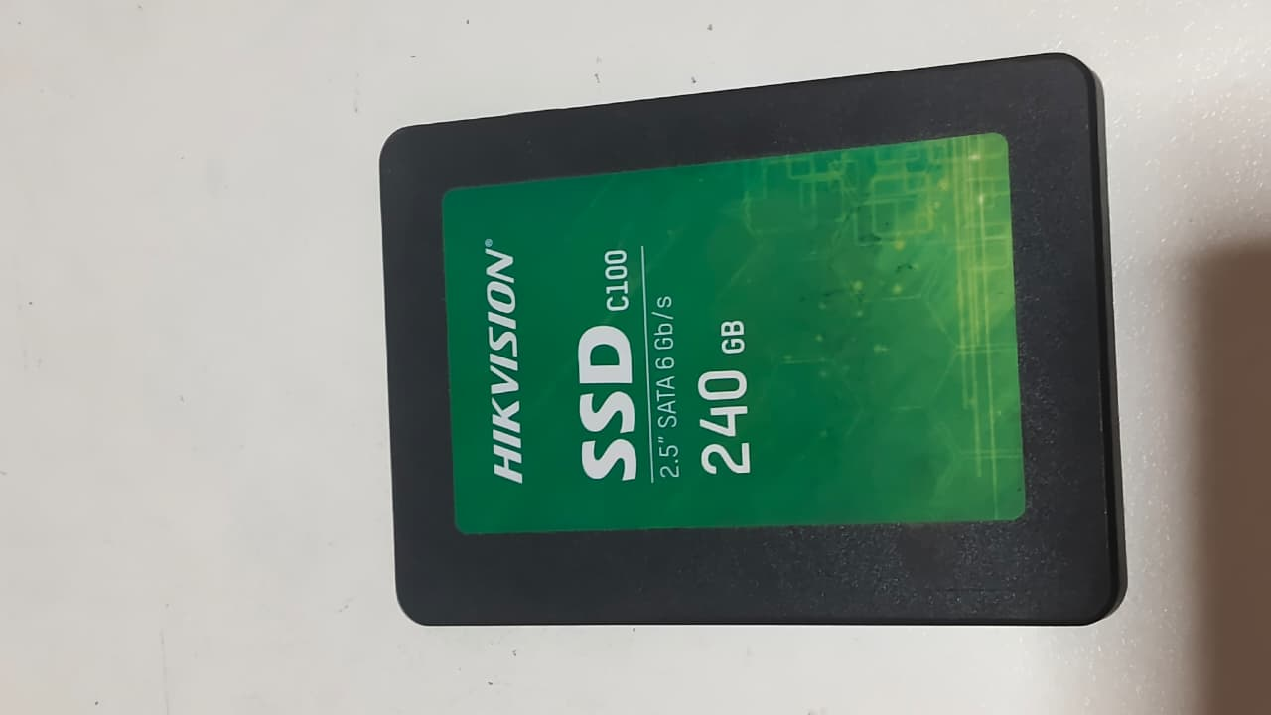

Step 7: Remove the Motherboard
Disconnect the remaining cables, remove the motherboard screws, and carefully lift the motherboard out of the case.
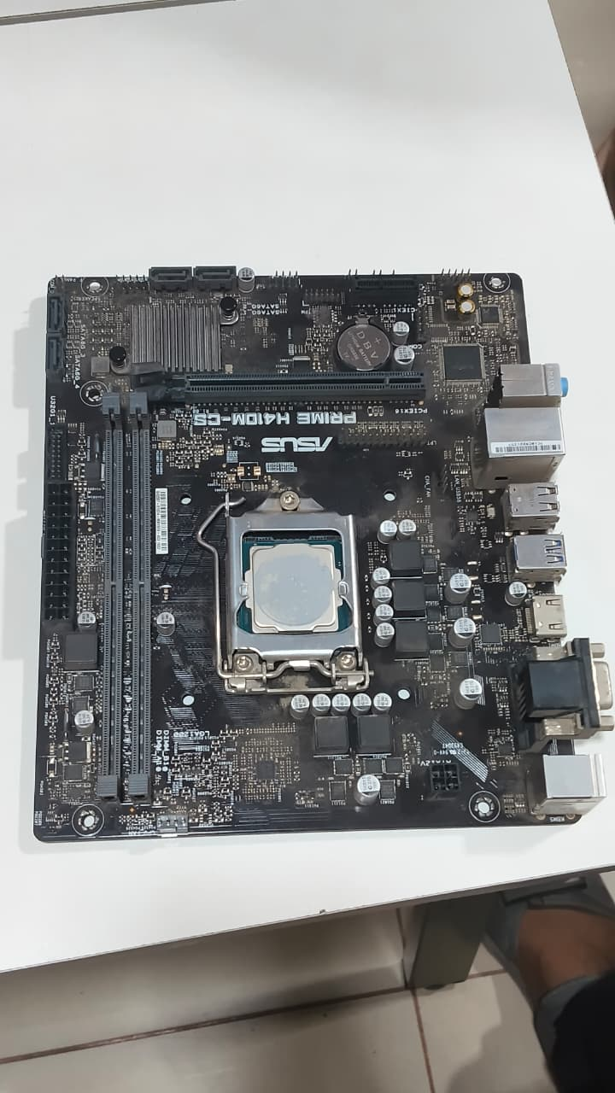
Step 8: Final Check
Keep all components and screws safely in one place for proper reassembly.

3. Reassemble the PC you disassembled, documenting each step with a brief explanation of what you connected or installed and why the order matters.

Step 1: Install the Motherboard
Caption:
The motherboard was placed inside the cabinet and aligned with the mounting holes. It was secured using screws.

Step 2: Install the SMPS/PSU
Caption:
The SMPS was placed in its position and secured with screws. The power cables were kept ready for connection.

Step 3: Install the CPU and CPU Cooler
Caption:
The CPU was placed into the CPU socket and locked. Thermal paste and the CPU cooler were installed properly.

Step 4: Install the RAM
Caption:
The RAM module was inserted into the correct DIMM slot until the locking clips clicked into place.

Step 5: Install the HDD/SSD
Caption:
The HDD/SSD was placed in its mounting position and secured properly.

Step 6: Connect Storage Cables
Caption:
The SATA data cable was connected between the motherboard and HDD/SSD. The storage power cable was connected from the PSU.

Step 7: Install the GPU
Caption:
The GPU was inserted into the PCIe x16 slot and secured with a screw. The required GPU power cable was connected.

Step 8: Connect Front Panel and Fan Cables
Caption:
The power switch, reset switch, USB, audio, and case fan cables were connected to the motherboard.

Step 9: Connect Main Power Cables
Caption:
The 24-pin motherboard power connector and 8-pin CPU power connector were connected securely.

Step 10: Close the Cabinet and Test
Caption:
The side panel was attached, the power cable was connected, and the PC was switched on.
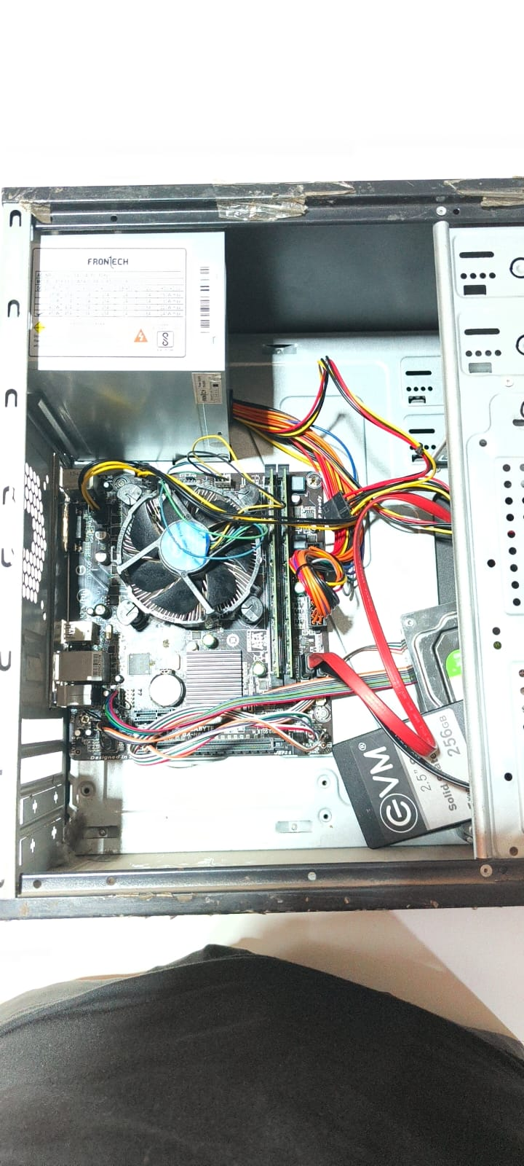

4.Create a checklist of safety precautions and tools needed before starting the PC assembly/disassembly process, and explain why each is important.

PC Assembly/Disassembly Safety Precautions
Safety Precaution | Why It Is Important
Turn off the PC | Prevents electrical accidents and hardware damage.
Unplug the power cable | Completely disconnects the PC from electricity.
Use an anti-static wrist strap | Protects components from static electricity.
Work on a clean and dry surface | Prevents dust, moisture, and accidental damage.
Handle components by their edges | Protects sensitive electronic parts and connectors.
Keep screws safely | Prevents losing screws during assembly or disassembly.
Do not force components | Prevents damage to slots, ports, and connectors.
Keep liquids away from the PC | Prevents short circuits and hardware damage.
Use the correct tools | Prevents damage to screws and components.
Check all connections before powering on | Ensures the PC is connected correctly and safely.

